RESUME 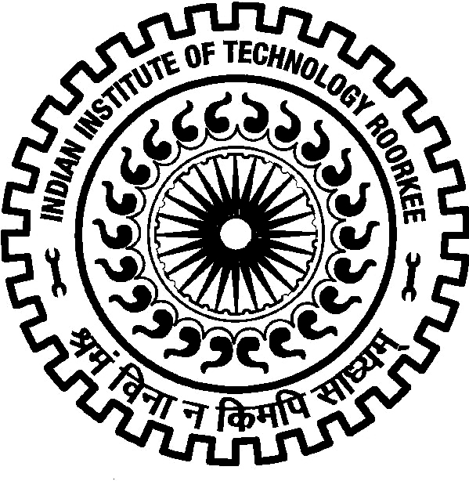

ARNEPALLI PRAMODH, Indian Institute of Technology Roorkee
Hno 1-5-112
New maruthinagar,
Hyderabad - 500060
Phone No-8801311444 Email ID:pramodh33@gmail.com
Objective:

- To associate with an organization that gives me a chance to prove my knowledge
and efficiency and enhance my technical skills to be a part of
a team that excels in work towards the growth of the organization.
Educational Qualifications:

Projects:
Educational Qualifications | Year | Board/Institution | CGPA* / %
M.Tech | 2013 | IIT Roorkee | 8.69
UG Overall | 2011 | Chaitanya Bharathi Institute of  Techonology | 75.94
Twelth | 2007 | Narayana Jr college | 94.4
Tenth | 2005 | St Claire Convent High School | 82.83

SUMMER INTERNSHIP
Topic: Project on high rise construction management
Organization Name: Lanco Infratech Limited, Hyderabad

Topic: Key issues in construction business management
Organization Name: National academy of construction

ACADEMIC
Topic : Use Of Plastics As Constituent Material Of Roads
Organization Name: Chaitanya Bharathi Institute Of Technology

Topic: Influence of LWR track on fatigue of steel bridges.
Organization Name: IIT Roorkee

Technical Skills:

- Languages : C, C++.
- Others : AutoCAD, SAP,STAD pro, MATLAB,
.NET,HECRAS,SAFE.
Strengths:

- Good communication and presentation skills.
- Willingness to learn and adaptability to put learning into practice.
- Adaptable to environmental changes and emerging trends.
- Tenacity in problem solving.
- Comfortable to work in shifts.
Achievements:

- Stood First in State Level inter School Badminton Competitions.
- Achieved an all India rank of 312 in gate 2012.
- Secured 1st place in technical quiz competition at IIT Roorkee.
- Got selected as a captain in school Yellow (TAGORE) team .
- Worked as co convener for cognizance, the technical fest of IIT Roorkee.
- Organized technical event (BOB THE BUILDER) in CIVILIZATIONS-2010.
- Got selected as the class representative of CARPEDIUM(cs)event of CBIT .
- Achieved a title of ALLROUNDER in my school .
Experience:

- Worked in Government of Telangana for 7 years as Assistant Executive Engineer.

- Gained Experience in Scrutiny and Vetting of designs and drawings of EPC and NON EPC works pertaining to various irrigation structures such as Barrages, Tunnels ,Bridges, Head regulators etc.
- Worked in design and research of ANNARAM Barrage (a part of India’s largest Lift Irrigation scheme,Kaleshwaram).
- Worked in Automation of civil designs in V.B.NET for achieving speed and efficiency in designs.

Personal Profile:Preference

Father’s Name : A.Vasanth Kumar
Sex : Male
Date of Birth : 01-09-1989.
Languages Known : English, Hindi & Telugu.
Declaration:

I hereby declare that the information furnished above is true to the best of my knowledge.

A.Pramodh

